Daniel Schroeder’s Ocean Explorer Users Manual

Story
The adventure begins when a marine biologist, played by you, and his colleagues decide to take a trip to the Artic in search of new species of marine life. After several weeks of fun, but uneventful dives you and your crew come across a huge water filled cavern in the middle of a gigantic iceberg. After observing that there are in fact fish living in the water, you decide to lower the submarine into the cavern to take a closer look…

Play Modes

Free Swim – In Free Swim mode, there is no objective and no way to “beat the level”. You can simply swim around and collect fish for as long as they like. To enter Free Swim Mode, press the Enter key when in the Main Menu.

Normal Game – When playing a Normal Game you will need to complete an objective or achieve a goal to advance to the next level. The levels objective is displayed before starting each level, and it is also displayed near the bottom of the screen when playing the level. If you die or do not complete the levels objective in time, you must restart the level. You can die and replay the level as many times as you like, but if you return to the Main Menu you will have to restart the game from the first level. To begin a Normal Game, press the Space Bar when in the Main Menu.

Controls

Menu Controls:
Escape key – Returns to the Main Menu, or if already there, exits the game
NOTE: If you are playing the game then return to the Main Menu, you
will have to restart the game from the first level
Space Bar – Advances to the next screen or starts the game play
Enter key (when in the Main Menu) – Enter Free Swim mode
Tab – Display how many FPS (Frames Per Second) the game is rendering

In-Game Controls:
Up / Down arrows – Move the submarine forward / backward
Left / Right arrows – Rotate the submarine left / right
Space Bar / Left Mouse Button – Move submarine upwards towards the surface
Right Mouse Button (Hold it and move the mouse) – Look around

Y – Toggles the Y-axis reversal for when “Looking around” with the mouse
1 – Switches the camera to a 1st person view
2 – Switches the camera to a 3rd person fixed view (stays in a fixed position)
3 – Switches the camera to a 3rd person chase view (follows the submarine)
X / Z or Mouse Scroll Wheel – Zoom the camera in / out (only when in 3rd person
chase view)
Enter key – Toggles between using the player camera, using the shark camera,
or using both with a split screen
NOTE: The camera view can only be changed using the player camera

Escape key – Return to the Main Menu
NOTE: If you are playing the game then return to the Main Menu, you
will have to restart the game from the first level
Tab – Display how many FPS (Frames Per Second) the game is rendering

Developer Main Menu Controls (Cheats):
1 / 2 / 3 / 4 / 5 – Load level 1 / 2 / 3 / 4 / 5

Developer In-Game Controls (Cheats):
W – Instantly Win (beat) a level H – Instantly gain a Health point
D – Instantly Die and lose the level T – Instantly gain more Time
Right Shift key – Toggle between displaying the levels objective and debug info

In-Game On-Screen Information
Health Time Score

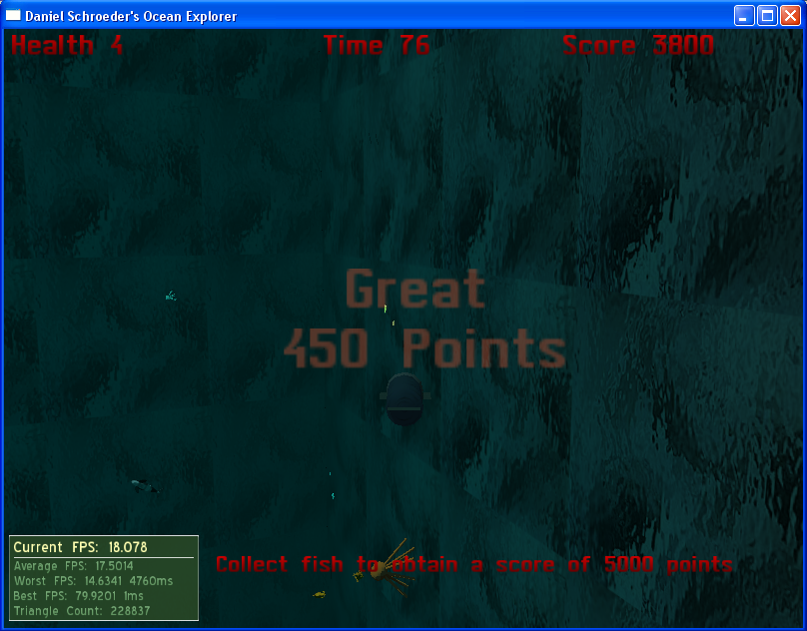

FPS Objective Submarine Points Earned
Health – How much damage the submarine has sustained from the shark. If the submarines health reaches zero, you must restart the level. An additional health point is rewarded for every 2500 points obtained.

Time – If the level has a time limit the Time will count down. If the Time reaches zero before you are able to complete the levels objective, you will have to restart the level. If the level does not have a time limit the Time will count up. This does not have any bearing on the game and simply lets you know how long you have been playing the level for.

Score – The number of points you have obtained in the current level. An additional health point is rewarded for every 2500 points obtained.

FPS (Frames Per Second) – How many frames (images) are being displayed per second. If the FPS is too low, the game will appear to be very choppy. In this case try playing the game on a faster computer or one with a better video card.

Objective – The goal of the level which needs to be completed in order to advance to the next level.

Submarine – The submarine which you are controlling. You must get the submarine close enough to fish in order to catch them.

Points Earned – The number of points gained from catching a fish. Each time you catch a fish the number of points gained from it will be displayed on the screen for about one second. Different fish are worth different amounts of points.

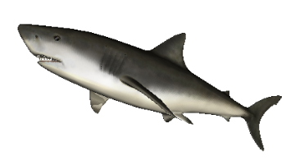
Types of Fish

Shark – The Shark is mean and hungry. It has been at the top of the food chain in the ice cavern for a very long time, and does not like that the submarine has entered its territory. Watch out for the Shark as it is very strong and may cause damage to the submarine.

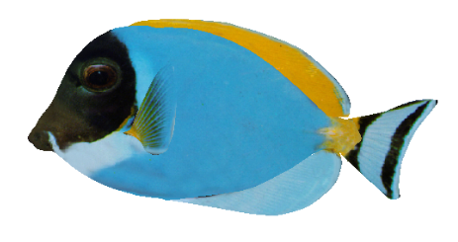
Blue Fish – While the Blue Fish isn’t very big compared to the other marine life in the cavern, he is fairly fast. Blue Fish like to swim in schools and are worth a cool 500 points each, so keep you eye open for them.

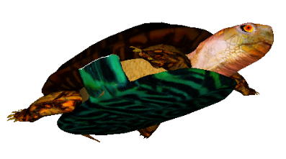
Ice Turtle – Normally turtles aren’t found in such cold regions, but this turtle has developed a tolerance for the cold. Like most turtles the Ice Turtle doesn’t move very fast, but it can grow up to hefty 3 meters in length. The Ice Turtles large size, colorful shell, and slow speed make it an easy target to catch, but it is only worth 150 points.

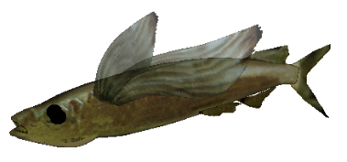

Parexo Fish – Parexo Fish are easy to spot with their wing-like fins. These fish prefer to swim in schools, and can be very evasive when they sense they are in danger. The Parexo Fish is worth a modest 375 points.

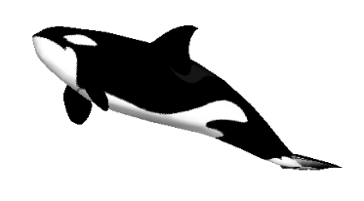
Killer Ice Whale – The Killer Ice Whale despite its name is quite docile, and its thick layers of fat allow it to swim in the coldest of waters. While the Killer Ice Whale seems to prefer to stay amongst other Ice Whales, it is not often seen swim with other Ice Whales. Killer Ice Whales on average grow to be 7 meters in length, travel fairly quickly, and are worth a large 700 points.

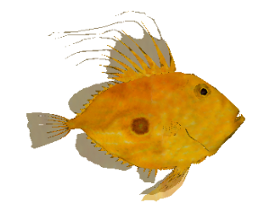

Golden Fish – While Golden Fish are easy to spot because of their distinctive color, catching them is another story. These fish are very fast and do not hang around when they sense that they may be in danger. The elusiveness of these fish makes them worth a whopping 1000 points.

These are only a few of the fish found in Daniel Schroeder’s Ocean Explorer, so keep you eyes open for other types of fish. Hint: Many types of fish prefer to stay close to the caverns walls where it is safer.

